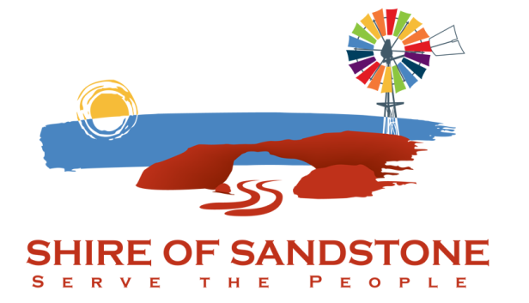

Shire of Sandstone

Project/Grants Officer

Application Package

Project/Grants Officer

Are you interested in making a difference in your community? Do you enjoy working in a team environment and have an affinity for a welcoming and relaxed rural lifestyle?
If so, an opportunity has arisen for Grants / Project Officer with the Shire of Sandstone.

Initially the position will be a two-year fixed contract and reassessed prior to the end of the contract.
Our ideal candidate will be highly organised with good attention to detail and previous experience. You will be able to work effectively in a team, show initiative, and be able to multi-task to meet deadlines.
This position offers a competitive remuneration package and five (5) weeks' annual leave.
Employment and salary conditions are in accordance with the Local Government Award 2021. With an attractive cash renumeration package in the range of $80,000 to $92,500
Subject to availability, rent free staff housing may be provided.
Written applications clearly marked "Project/Grants Officer" and containing full personal details, work experience and the names of two (2) work related referees should be forwarded to the Chief Executive Officer. Application closes 31/5/2021.

Charlie Brown
Chief Executive Officer
Hack St, Sandstone WA 6639
Telephone: 9963 5802
Email: ceo@sandstone.wa.gov.au
www.sandstone.wa.gov.au

Shire of Sandstone

Attraction and Retention Performance Scheme

In an effort to provide an incentive for staff to remain with the Shire of Sandstone, a performance based reward system recognising good performance during the year and longevity of service applies to all full-time, part-time, casual and contract staff, with part-time and casual employees being entitled to a pro-rata percentage calculated on the number of ordinary hours worked during the calendar year from 1 December to 30 November.
The following amounts, or a proportion thereof, will be paid to employees in the first pay period after 1 December annually, based on the following thresholds being reached:
First year of employment up to 30 November (qualification period)
will attract a pro-rata entitlement of up to $3,000
First full year after qualification: $4,000
Second full year after qualification: $5,000
Third full year after qualification: $6,000
Fourth full year after qualification: $7,000
Subsequent years: $7,500
Employees forfeit their entitlement to any service recognition payment where they part Council’s employ after 1 December. A part-entitlement of the applicable amount may be payable for new employees that commence part way through the year.

About Sandstone

The Shire of Sandstone is in the Murchison region of Western Australia and covers an area of approximately 32,889 square kilometres. The town of Sandstone is the administrative centre of the Shire.
Gold was the original catalyst for settlement in the region having first been found in the early 1890’s. The gold industry has fluctuated ever since, however several future prospects are on the horizon as the Sandstone area is rich in gold and other mineral deposits including vanadium, uranium and iron ore.
The pastoral industry is one of the other main economic activity in the region, having been established in the early 1900’s and continues today with some landholdings of up to 400,000 hectares.
The new industry Council is focusing on is tourism.
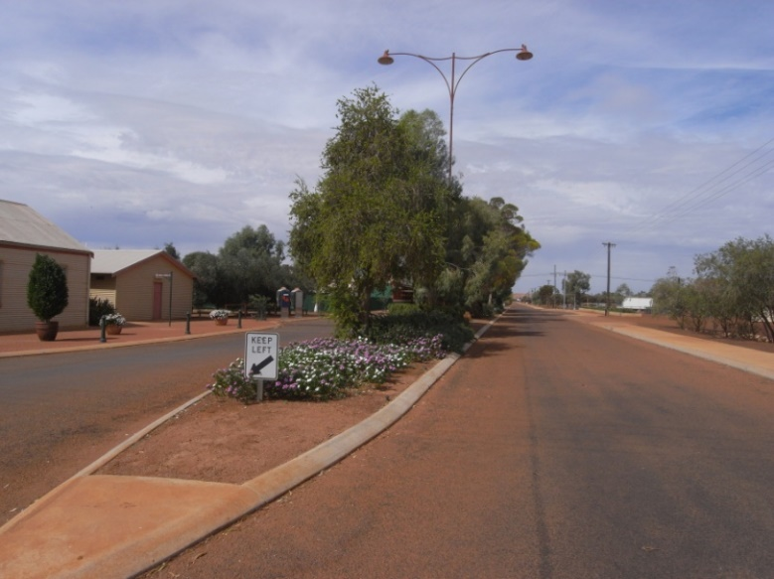
The townsite of Sandstone was gazetted in 1906 and the population grew to a peak of about 3,000 in 1920. The permanent population of the Shire is now approximately 110. The resident population of the Sandstone townsite itself is about 60.
The town is serviced by a Nursing Post, Royal Flying Doctor medical staff, Hotel/General Store, Post Office Agency, fuel and LPG gas outlet, Caravan Park, airstrip and private accommodation units. An 18-hole golf course (which is rumoured to have one of the longest par-4 holes in the Southern Hemisphere) and a floodlit bowling green are available for recreation activities.
Sandstone is approximately 724 kilometres northeast of Perth by sealed road via Mount Magnet (or 650km direct from Paynes Find) and is halfway between Mount Magnet and Leinster. Sandstone experiences very hot, dry summers and temperate winters. In the spring there are often spectacular displays of wildflowers and there is also an abundant array of wildlife in the region.
Within the Sandstone townsite and throughout the surrounding region there is a wonderful range of natural and built heritage that is a popular drawcard for locals and tourists alike.

The Shire has focused on restoring and preserving several older buildings and structures and in recent years has developed the “Gold & Wool Interpretive Park”, a museum and a large photographic display depicting both the history and heritage of the area and of the district today. Sandstone has become a favoured stopover place for visitors from the Eastern States travelling to destinations in the North West of Western Australia via Kalgoorlie and Sandstone to Great Northern Highway. The town is socially stable and has very little crime.
There are many exciting opportunities to develop and progress the Shire of Sandstone, including the ongoing improvement of its road infrastructure, the building of a new Shire Office/Civic Centre and the restoration and display of heritage structures. It is also expected that opportunities will present themselves in the areas of carrying out private works for mining companies and other agencies. The community is passionate about retaining the Shire of Sandstone as a separate local government entity and is supportive of the efforts of the Council in this regard. The Shire is in an exceptionally strong financial position, has a committed Council, multiskilled and cooperative staff, up to date plant and equipment and modern housing for its employees.

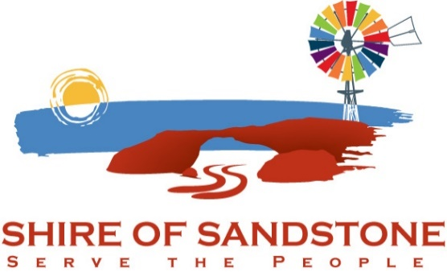

Shire of Sandstone

POSITION DESCRIPTION

Position Title: Project/Grants Officer

Level: Contract

Division: Administration

Responsible to: Chief Executive Officer

Position Overview
.wa.gov.au
- To work collaboratively with internal and external stakeholders to help develop ideas and concepts into deliverable projects
- To contribute to the effective and efficient delivery of projects from idea through to successful completion including project scoping, planning, design, resourcing, implementation and commissioning.
- To supervise project implementation including contract administration, stakeholder engagement and project reporting
- To provide technical and project advice, to a variety of internal and external stakeholders.
- Successfully deliver the annual capital works program in relation to projects
- Assist council in sourcing external funding to leverage Councils funds for its capital works, service delivery programs and special initiatives.
Key Duties and Responsibilities
- The effective delivery of assigned capital projects.
- Provide supervision in relation to project delivery, including project formulation (Scope planning, budgeting and programming), the development of consult and design briefs, management of subsequent engagements and as necessary issue resolution.
- Prepare contract documentation including drawings, specifications and other items specific to individual projects.
- Effectively supervise construction phase of projects to ensure projects are delivered on time, on budget and to specifications set out in contracts.
- Ensure that effective project reporting mechanism are implemented meeting the needs of the Chief Executive Officer, and Councillors.
- Ensure effective communications and liaison processes with stakeholders including the Chief Executive Officer, Works Supervisor and Councillors are implemented.
- Research, identify & maintain a register of external funding sources & opportunities that are relevant to council’s area of operation, and/or support the growth and development of the council.
- Preparation of grant applications.
- Carry out other duties as deemed reasonable and appropriate to the role as directed from time to time by the Chief Executive Officer.

Specialist Knowledge and Skills
- The person will be required to monitor and make decisions relating to the budget, in consultation with the Chief Executive Officer.
- Sound knowledge of project management principals, including construction management
- Ability to support and work efficiently with recreational and community groups
- Understand the processor of developing specifications and monitoring projects
- Ability to respond to unplanned issues
- Proficiency in use of personal computer, including word processing, spreadsheet and database software.
Management Skills
- An ability to efficiently manage time, constantly re-prioritising task to work on a number of tasks simultaneously and respond to immediate needs.
- An understanding and ability to implement policies and practises.
- Possession of well-developed organisational skills.
- Effective use of available resources.
- Ability to work methodically and diligently
Interpersonal Skills
- Demonstrated ability to liaise effectively with Councillors, council staff and residents
- Ability to gain co-operation and support of others to achieve set objectives and in the administration of well-defined activities.
- Oral communication skills of an order sufficient to communicate clearly with staff, customer, community groups and contractors.
- Written communication skills of an order to effectively prepare report and external correspondence on matters relating to the position.
- Ability to respond positively to change
- Ability to demonstrate integrity, responsibility, innovation and respect in all aspects of the position.
Qualification and Experience
- Several years’ experience in Project management
- Demonstrated experience in successful grant applications.
- Demonstrated experience in community liaison and project partner relationships
- Current Motor Drivers licence is essential
Key Selection Criteria
- Demonstrated experience in project management
- Demonstrated experience in the use of judgement to enable quality decision making with a project management context.
- Demonstrated ability to build partnerships with a range of stakeholders (both external and internal) to achieve optimal outcomes.
- Demonstrative interpersonal, communications and consultation skills.
- Demonstrated experience in successful grant applications.
- A good knowledge of the construction industry and an understanding of local government
- Demonstrated ability to work both independently and as a member of a team, often working to strict deadlines.

